**Kinematics Design Project**

**Nguyen Vo, Panayioti Panayi, Hunter Bertsch**

**Dr. Kang**

**30 November 2017**

**Introduction**

In this report, the task assigned was to design a personal joy ride using a 4-bar or 5-bar mechanism. In order to make sure the rider doesn’t black out, a coupler point was chosen where an analysis was produced in order to determine the position, velocity, and acceleration of the rider. An analysis of the 4 bar linkage was done in order to determine the forces exerted on each bar and charts were created. A torque analysis was then conducted along with a joint force analysis. In order to verify each of these procedures in MATLAB, another analysis of the linkage was rendered using SOLIDWORKS. The picture of the joy ride created is shown below. The half circle and rectangle represents the mass of the person.

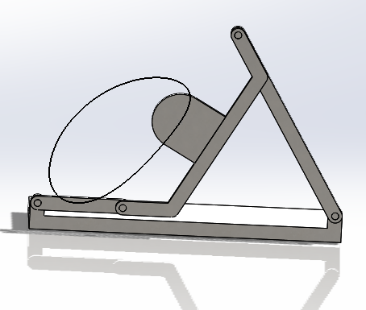

**Figure 1:** Picture of joy ride

**Determined what mechanism it is**

A crank rocker was chosen for analysis due to the configuration that occurs when it is running. Due to it being a crank rocker, a rotary motor will give the torque necessary to power it. In order to show what a crank rocker is defined as, this definition was used.

S=Shortest Link

L=Longest link

S+L<Sum of remaining link

Within the design, S+L is less than the remaining sum of the links showing that this is grashoff. For a crank rocker, the shortest link must also be adjacent to the ground link. Due to this condition being satisfied there is no way the linkage chosen could be a triple rocker or double rocker.

**Kinematic Analysis of the Rider**

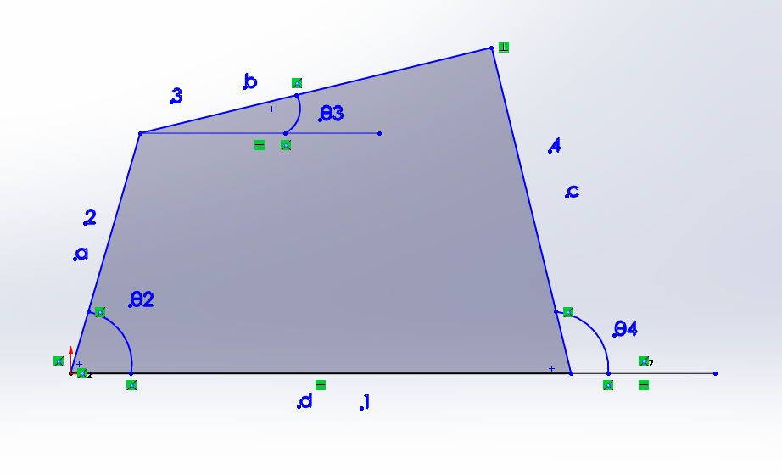

**Figure 2:** Shows what angles and bar numbers were used in MATLAB and SOLIDWORKS

Initially, a kinematic analysis was done using MATLAB and SOLIDWORKS of the coupler point in order to make sure the rider would be safe throughout the ride. The graphs were then compared with the MATLAB graphs in order to verify it was correct. An analysis of a bar was first done to verify the coupler point analysis would be accurate.

How we did kinematic analysis of each bar

Position: $ae^{iθ}+be^{iθ}$ + $ce^{iθ}+de^{iθ}$

Velocity $iω_{2} ae^{iθ2}+iω_{3} be^{iθ3}+iω_{4} ce^{iθ4}+iω_{1} de^{iθ1}$

Real: a $ω2sinθ2$ + b $ω3sinθ3+cω4sinθ4+dω1sinθ1$

Imag: a $ω2cosθ2$ + b $ω3cosθ3+cω4cosθ4+dω1cosθ1$

Acceleration:

Real: $-aα_{2}sinθ_{2}-aω_{2}^{2}cosθ_{2}-bα_{3}sinθ_{3}-bω_{3}^{2}cosθ_{3}-cα_{4}sinθ_{4}-cω_{4}^{2}cosθ_{4}-dα_{1}sinθ_{1}-dω_{1}^{2}cosθ_{1}$

Imaginary: $aα_{2}cosθ_{2}-aω_{2}^{2}sinθ_{2}+bα_{3}cosθ_{3}-bω_{3}^{2}sinθ_{3}+cα_{4}cosθ_{4}-cω_{4}^{2}sinθ_{4}+dα_{1}cosθ_{1}-dω_{1}^{2}sinθ_{1}$

SOLIDWORKS and MATLAB Chart. The graphs of both MATLAB and SOLIDWORKS of the bar linkage show that the coupler point analysis should be accurate as well and match up with each other. This chart is a test chart to test whether the code and model will match up or not.

**Figure 3:** Angular Displacement vs.Theta

Next a match between the MATLAB and SOLIDWORKS was generated for the coupler point for position, velocity, and acceleration plots. In order for the coupler points in MATLAB to be graphed a kinematic analysis of the 4 bar linkage had to be done first. Only the position, velocity and acceleration of the rider are shown. For the parts interesting in this analysis, the maximum position, velocity, and acceleration will be used. The maximum position in x direction using MATLAB was 51.772 m. In the y direction it was 48.21 m. The maximum velocity in x direction was 168 m/s whereas in the y-direction it was 155.08 m/s. The acceleration is especially intriguing because it tells the g force the person experienced which was in the x direction 849.2 in/s2. In the y direction it was 458.6 in/s2.

Equation for x position of coupler point

$$acosθ_{2}+pcos⁡(θ_{p}+θ_{3})$$

**Figure 4:** Coupler Displacement x vs Theta

Equation for y position of coupler point

$$asinθ_{2}+psin⁡(θ_{p}+θ_{3})$$

**Figure 5:** Coupler Displacement y vs Theta

Equation for x velocity of coupler point

$$-aω_{2}sinθ_{2}-pω_{3}sin⁡(θ_{p}+θ_{3})$$

**Figure 6:** Linear Velocity x vs. Theta

Equation for y velocity of coupler point

$$aω_{2}cosθ_{2}-pω_{3}cos⁡(θ_{p}+θ_{3})$$

**Figure 7:** Linear Velocity y vs. Theta

Equation for x acceleration of a coupler point

$$-aα_{2}sinθ_{2}-ω_{2}^{2}cosθ_{2}-pα_{3}\sin\left(θ_{p}+θ_{3}\right)-ω_{3}^{2}cos\left(θ_{p}+θ_{3}\right)⁡$$

**Figure 8:** Coupler point acceleration x

Equation for y acceleration of a coupler point

$$aα_{2}cosθ_{2}-ω_{2}^{2}sinθ_{2}+pα_{3}\sin\left(θ_{p}+θ_{3}\right)-ω_{3}^{2}sin\left(θ_{p}+θ_{3}\right)⁡$$

**Figure 9:** Coupler point acceleration Y

**Joint Force Analysis**

The next step was to do a joint force analysis of each connecting point in the four bar linkage. A kinematic analysis was already finished in order to provide the position, velocity, and acceleration data. In order to provide comprehensive results, equations similar to the kinematic analysis were used. This was calculated using MATLAB and verified using SOLIDWORKS

Set up matrix to solve for each of the forces on each bar. Each row either represents the (sum of forces or sum of torques)-needs put in equation form. The equations with moment arms in them is the torque equation and the ones without are the force equations. The graphs were then based off of what each force was in the matrix. Each force had a naming convention where if the force was name F12 it means force of link 1 on 2. Throughout each graph, the SOLIDWORKS graph was used for maximum force because there was more accuracy involved.

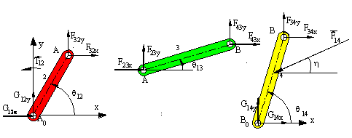

<http://ocw.metu.edu.tr/pluginfile.php/5791/mod_resource/content/8/ch6/6_2/6_2002.gif>

**Figure 10: How mechanism was analyzed**

Geometric Matrix Output matrix

1 0 1 0 0 0 0 0 0 F12x

0 1 0 1 0 0 0 0 0 F12y

-R12y R12x -R32y R32x 0 0 0 0 1 F32x

0 0 -1 0 1 0 0 0 0 F32y

0 0 0 -1 0 1 0 0 0 F43x

0 0 R23y -R23x -R43y R43x 0 0 0 F43y

0 0 0 0 -1 0 1 0 0 F14x

0 0 0 0 0 -1 0 1 0 F14y

0 0 0 0 R34y -R34x -R14y R14x 0 T12

Dynamic Matrix

m2*a2x

m2*a2y

I*alpha2

m3*a3x

m3*a3y

I*alpha3

m4*a4x

m4*a4y

I*alpha4

**Joint force analysis of F12**

The matrix shows how the analysis was done and how the forces and torques were inputted to provide the final answer of 258.34 lbf. These graphs show how SOLIDWORKS provides a graphical solution to the force of F12.

**Figure 11:** MatLAB and SolidWORKS F12 vs. Degrees

**Joint force analysis of F43**

The answer provided was done through the graphs as well coming out to be 116.46 lbf. The graphical solution plots how F43 reacts when a force is applied. It was verified by comparing SOLIDWORKS and MATLAB graphs. The reason the graphs are so off is due to an error in MATLAB. There could also have been an unaccounted for error in SOLIDWORKs as well.

**Figure 12:** MATLAB and SOLIDWORKS F43 vs. Degrees

**Joint force analysis of F14**

The answer provided was done through the graphs as well. The graphical solution plots how F14 reacts when a force is applied. The graphs don’t line up do to there being a possible error in the code or some unforeseen constraint in SOLIDWORKS. The force at F41 ends up being 130.4497 lbf.

**Figure 13:** MATLAB and SOLIDWORKS F14 vs. Degrees

**Joint force analysis of F23**

The answer provided was done through the graphs as well. The graphical solution plots how F43 reacts when a force is applied. It was verified by comparing SOLIDWORKS and MATLAB graphs. The force of F23 came out to be 455.29 lbf. This result seems reasonable. The graphs here comes close to matching it up to 200 degrees. Then the shapes of each start become very different. This could be in part due the SOLIDWORKS mechanism slowing down during the process.

**Figure 14:** MATLAB and SOLIDWORKS F23 vs. Degrees

**Torque Analysis**

A torque analysis of the 4 bar linkage was done in order to see how much horsepower would be needed in order to run the joy ride. The torque was calculated within the MATLAB matrix and a SOLIDWORKS analysis was also done in order to verify the amount of torque needed. The answer came out to be 19595 lbf-in.

**Figure 15:** MATLAB and SOLIDWORKS

**Conclusions**

The task assigned was accomplished and a thorough analysis of each link within the joy ride applied forces were obtained. With a maximum g force of 2.19 g’s it made for quite an exciting ride. The person will leave with a satisfactory thrill. Due to the acceleration not being too extreme, the child will still be safe while riding it. By matching both SOLIDWORKS and MATLAB the people will be safer for many future generations to come. The SOLIDWORKS provided a double check of the analysis MATLAB provided.

**Appendix**

Insert MATLAB code here